The whole algorithm cannot be done in PL, only applications which uses fixed algorithms can be offloaded into the PL.
For applications requiring user input and iterative algorithms we need the PS. The PS will also be responsible for the complex condition management and the drawing bounding boxes on the target in the output.
AXI – Advanced eXtensible Interface is the standard bus protocol used for communication between PS and PL. The pynq architecture provides python modules like Axi_GPIO, Axi_DMA.
DMA – It refers to the pynq.lib.dma modules that allows high speed transfer of data between the PS and an IP block using AXI stream, bypassing CPU for efficiency.
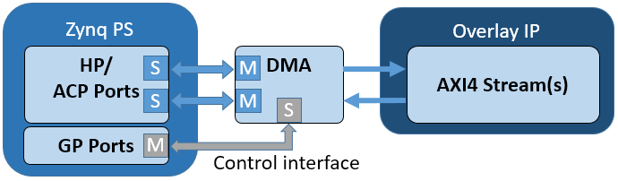

We will be using AXI HP ports, since they can be used for bulk data transfer and the width of the bandwidth is 32/64 bit. While the AXI GP ports are used for control signals transfer and they are generally 32 bit wide.
Process flow:
ZYNQ PS → DDR ← AXI HP ← AXI DMA ← IP(PL) → AXI DMA → AXI HP → DDR → ZYNQ PS → HDMI
Data flow:
USB Camera ZYNQ PS (capture) DDR (store frame) AXI HP0 (read access) AXI DMA - MM2S channel (AXI-Stream) Laplacian IP (PL) (AXI-Stream) AXI DMA - S2MM channel AXI HP0 (write access) DDR (store features) ZYNQ PS (CSRT + draw box) HDMI OUT
The data flow can be used as a reference for the Vivado block design.
ZYNQ Block:
- PS and DDR are inbuilt connection.
- DDR and AXI HP0 (port in Zynq block)
- The HP port will be connected to the Axi_DMA – MM2S using AXI_Lite wires
DMA Block:
- Axi_DMA – MM2S and Axi_DMA -S2MM are inbuilt channel in the DMA block.
- AXI-Stream will be the wires connecting the DMA block and the IP block.

MM2S: (Memory mapped to stream)
- Converts memory into AXI-Stream and sends it pixel by pixel to the PL
- DDR PL
S2MM: (Stream to memory mapped)
- Converts AXI-Stream output from IP and writes it as memory
- PL DDR
AXI-Stream is a handshake based protocol used to move data continuously without needing for address.
- TDATA = the actual pixel data (8-bit, 32-bit, etc.)
- TVALID = have valid data ready
- TREADY = ready to accept data
- TLAST = This is the last pixel in the frame

BRAM:
It is the memory used in the PL side (like DDR in the PS side). There is no need to import a Bram block since, it is present in the IP block. And the Hls will take care of the mapping between the bram and the IP block. We can use bram as a common buffer, so that Ip1 writes something in it and Ip2 reads the that from the bram instead of going back to DDR for every read and write.

Some Useful Tutorials: (in order)
- https://discuss.pynq.io/t/tutorial-creating-a-hardware-design-for-pynq/145
- https://discuss.pynq.io/t/tutorial-pynq-dma-part-1-hardware-design/3133
- https://discuss.pynq.io/t/tutorial-pynq-dma-part-2-using-the-dma-from-pynq/3134
- https://discuss.pynq.io/t/tutorial-using-a-hls-stream-ip-with-dma-part-1-hls-design/3344
- https://discuss.pynq.io/t/tutorial-using-a-hls-stream-ip-with-dma-part-2-vivado-design/3345
- https://discuss.pynq.io/t/tutorial-using-a-hls-stream-ip-with-dma-part-3-using-the-hls-ip-from-pynq/3346
- https://thedatabus.in/conv_acc/

Configuring the DMA:
The address bit should be 32 bit for DMA since our PS is only 32bit. And the buffer length Register can be set between 8-26, setting it as 26 bit allows us to transfer more data around 67,108,863 bytes.
Configuring PS block:
Under the PS-PL setting select the S_Axi_HP_0 and S_Axi_HP_2 and set their bandwidth to 64. HP_0 and HP_1, HP_2 and HP_3 share the switch to one port. So if we want two HP ports it is efficient to select the ports that don’t share the same switch. The data width for these HP ports are 64 bits.

Important links: https://youtu.be/RtwF194huLc?si=Papsw7MxguTKa01r , https://docs.amd.com/r/en-US/ug1399-vitis-hls/Refactoring-C-Source-Code-for-HLS ,
https://github.com/Xilinx/Vitis_Libraries/tree/master/vision/L2

